Shaan Barkat

Mr. Grady

IT 223

6 January 2017

Assignment 1

1.1

(8:05 + 7:49 + 8:43 + 7:50 + 11:47 + 7:31)/6 = 8:38PM (~8:37:30) \*calculated by minutes but for convenience typed times.

Late by: 48 minutes, (~47:30 minutes)

1.2

There definitely was an outlier, the flight that arrived at 11:47PM caused the mean to shift up in time drastically because all the other arrivals were somewhat close to the destined arrival time (7:50PM). Also if you do the math between the expected arrival and the outlier arrival we see just how big the difference is, for instance, 11:47PM (-) 7:50PM is a whopping 237 minutes of overlay compared to the second highest of just 53 minutes. For that reason, the mean would not be an ideal statistic for determining the center of distribution.

1.3

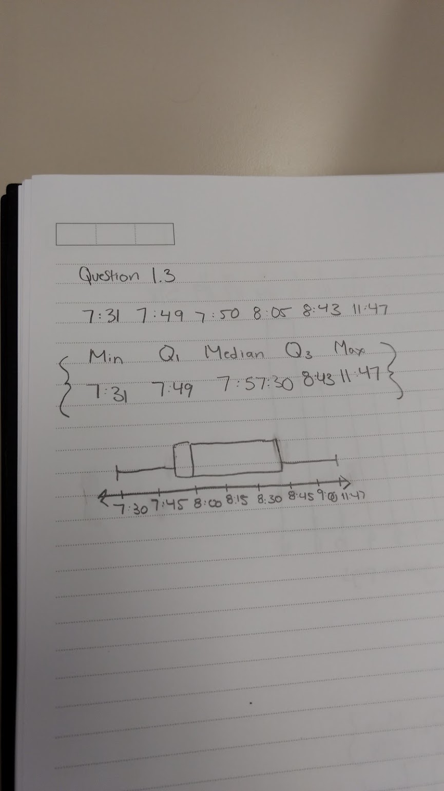

2.1

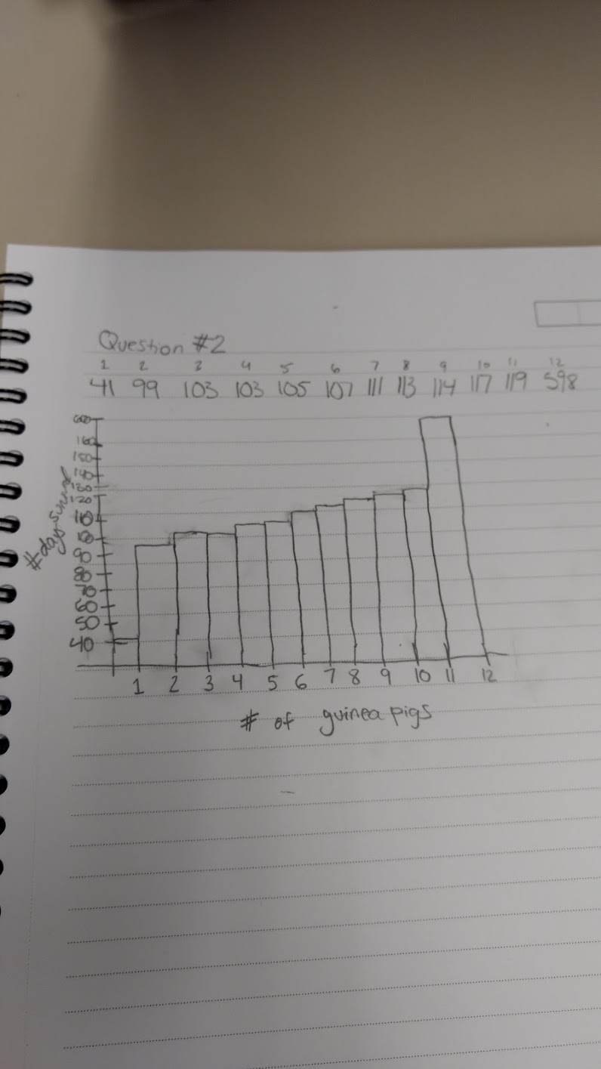

2.2

The survival times were all close to one another except one outlier that made the histogram become a left skew. That outlier was the one guinea pig that survived 598 days.

2.3

The outlier guinea pig had a 479 day difference with the second highest surviving guinea pig, with that said, clearly this one guinea pig disrupted the distribution mean of the other guinea pigs because they were all within the range of 80 days or so.

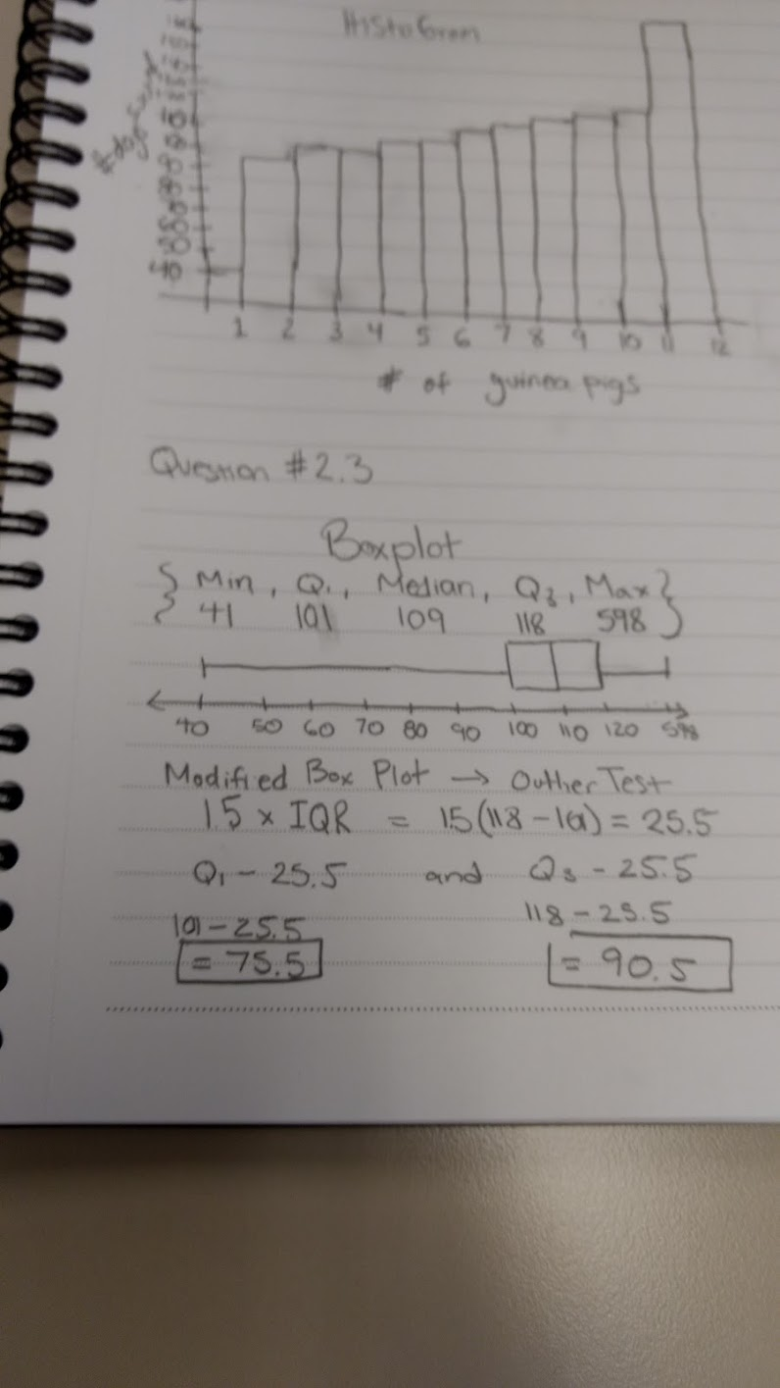

3.1

In this article, we how students retain information given through lectures by their professors. In the given graphs, we see that students who retain the most out of the lecture always go back the next day to review what they have learned. In the article, we see the amount of information lost due to not reviewing the content. This is because our short-term memory is not capable of lasting 2 or more days without deuterating memory on that subject. Furthermore, the article states that “if you have done nothing with the information you learned in that lecture, didn't think about it again, read it again, etc. you will have lost 50%-80% of what you learned”. This percentage of knowledge is enormous, so, in order to retain that information, students, like me, should review the content on a daily basis in order to succeed in the classes that they are currently enrolled in and in the future.

4.1

(687+692+681+598+789+763+990+490)/8

Mean: 707.875

4.2

490, 598, 681,[687, 692], 763, 789, 990; (687+692)/2

Median: 689.5

5.1

